Supplementary Material For

A Facile Method for Precise Layer Number Identification of Two-Dimensional Materials through Optical Images

Jiayu Leiª, Jiafan Quª, Peng Wangª, Hu Jiangª, Hongyan Shi^{a, b}, Xiudong Sun^{a, b}, and Bo Gao^{a, b, *}

ª Institute of Modern Optics, Department of Physics, Key Laboratory of Micro-Nano Optoelectronic Information System, Ministry of Industry and Information Technology, Key Laboratory of Micro-Optics and Photonic Technology of Heilongjiang Province, Harbin Institute of Technology, Harbin 150001, China
^{b} Collaborative Innovation Center of Extreme Optics, Shanxi University, Taiyuan 030006, China
* Corresponding author. E-mail: gaobo@hit.edu.cn

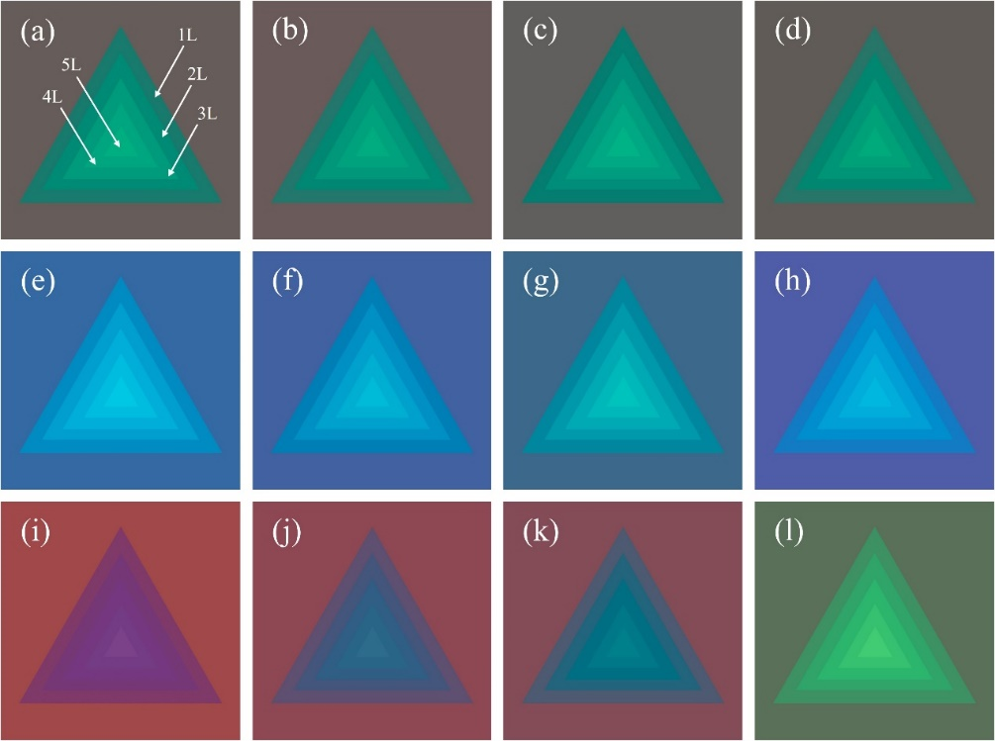
Fig. S1. Calculated optical images of MoS₂ nanosheets on SiO₂/Si substrate observed by CIE standard observer under different illuminants (a) CIE Standard Illuminant A [1] (specified condition) (b) Thorlabs OSL2 [2] halogen light source (c) Philips 7724 [3] halogen lamp (d) Thorlabs SOLIS-2C [4] LED illuminant (warm white) (e) Thorlabs HPLS343 [5] High-Power Plasma Light Source (f) Thorlabs SOLIS-1C [4] LED illuminant (cold white) (g) Thorlabs SOLIS-3C [4] LED illuminant (daylight white) (h) Leica KL 300 [6] LED illuminant. Calculated optical images of MoS₂ nanosheets on SiO₂/Si substrate with different oxide thickness observed by CIE standard observer under CIE Standard Illuminant A (specified condition) (i) 270 nm (j) 280 nm (k) 285 nm (l) 315 nm.
Fig. S2. Color differences between MoS₂ nanosheets and SiO₂/Si substrate versus layer number by different illuminants (a) before (b) after image reconstruction; by different color matching functions of several cameras (c) before (d) after image reconstruction; by different AWB algorithms (e) before (f) after image reconstruction.
Fig. S2 shows the color difference versus layer number before and after reconstruction. In Fig. S2(a), color difference curves between MoS₂ nanosheets and SiO₂/Si substrate versus layer number under several illuminants are shown. Thorlabs SOLIS-2C [4] and Leica KL 300 [6] are LED illuminants; Thorlabs OSL2 [2], Phillips 7724 [3] are halogen illuminants; Thorlabs HPLS343 [5] is high-power plasma light source; all of them are designed for optical microscopes. CIE Standard Illuminant D65 [1] is a commonly used standard daylight illuminant. After image reconstruction, all curves approach to that under the specified condition, as shown in Fig. S2(b).
Fig. S2(c) are color difference versus layer number from optical images taken by cameras with special color matching functions under illuminant A [1]. Here we take Thorlabs CS505CU [7] CMOS cameras, Edmund Optics-0413C camera with uEye MT9V032 [8] CMOS and Point Grey Grasshopper 50S5C [9] CCD camera as examples. After reconstruction, in Fig. S2(d), there are only slight differences between reconstructed image and image under the specified condition.
After calibration with Auto White Balance (AWB) methods, Gray World method [10], White Patch Retinex [10] and Linearize gamma-corrected [10], color difference versus layer number is shown in Fig. S2(e). After reconstruction, all curves in Fig. S2(f) approach to the specified condition, indicating the feasibility of our method.

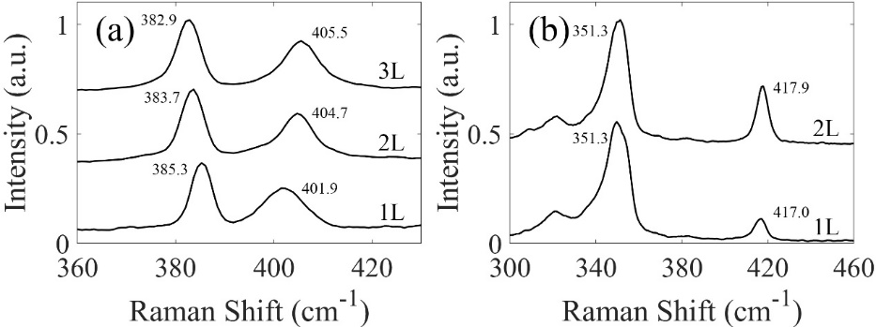
Fig. S3. Raman spectra of our samples with normalized intensity (a) MoS₂ (b) WS₂. $E_{2g}^{1}$ and $A_{1g}$ of MoS₂, 2LA and $A_{1g}$ of WS₂ are marked.
Fig. S4. Raw images from published papers, and corresponding reconstructed images and layer number images. (a) WS₂ [11] (b) MoS₂ [12] (c) MoS₂ [13] (d) MoS₂ [14] (e) WS₂ [15] (f) our WS₂ samples.

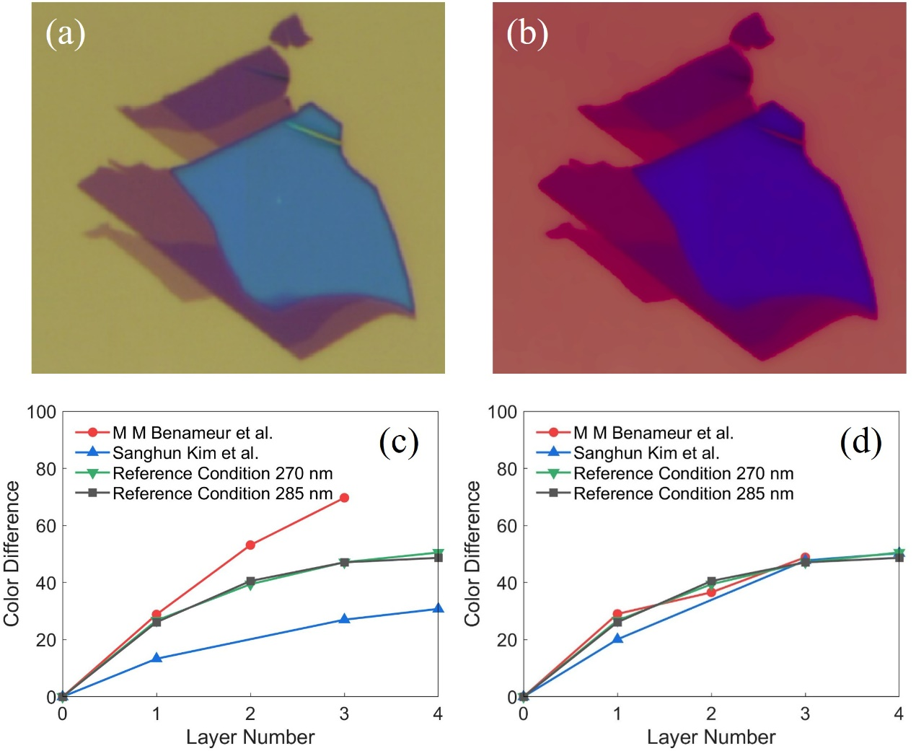
Fig. S5. Optical images of WSe₂ nanosheets [16] (a) before and (b) after image reconstruction. Color differences between WSe₂ nanosheets [16, 17] and 270, 285 nm SiO₂/Si substrate versus layer numbers (c) before and (d) after image reconstruction.

TABLE SI. Color difference values in Fig. 3
Layer number | 0 | 1 | 2 | 3 | 4 | 5
Specified condition | 0.0 | 33.6 | 41.9 | 48.1 | 53.6 | 58.3
D65-Eye | 0.0 | 17.2 | 26.1 | 34.5 | 41.1 | 46.6
Reconstructed D65-Eye | 0.0 | 35.8 | 43.7 | 48.9 | 52.8 | 56.4
A-MT9V032 | 0.0 | 39.5 | 63.0 | 77.0 | 83.3 | 83.8
Reconstructed A-MT9V032 | 0.0 | 38.0 | 45.2 | 49.7 | 53.2 | 55.3
A-Eye-Gray World | 0.0 | 59.1 | 68.3 | 74.9 | 80.4 | 84.5
Reconstructed A-Eye-Gray World | 0.0 | 31.2 | 39.5 | 48.8 | 56.2 | 62.0
TABLE SII. Color difference values in Fig. 4, MoS₂
Layer number | 0 | 1 | 2 | 3 | 4
Specified condition | 0.0 | 33.6 | 41.9 | 48.1 | 53.6
Ref. 27 | 0.0 | 16.3
Reconstructed ref. 27 | 0.0 | 34.0
Ref. 28 | 0.0 | 43.1
Reconstructed ref. 28 | 0.0 | 34.0
Ref. 29 | 0.0 | 23.9 | 41.8 | 54.3 | 61.8
Reconstructed ref. 29 | 0.0 | 32.5 | 45.4 | 48.2 | 54.8
Our sample | 0.0 | 55.4 | 62.7 | 66.9
Reconstructed our sample | 0.0 | 36.6 | 41.2 | 46.4

TABLE SIII. Color difference values in Fig. 4, WS₂
Layer number | 0 | 1 | 2 | 3 | 4
Specified condition | 0.0 | 30.4 | 42.4 | 48.6 | 54.4
Ref. 30 | 0.0 | 18.9 | 26.7 | 32.1
Reconstructed Ref. 30 | 0.0 | 29.9 | 39.6 | 53.1
Ref. 31 | 0.0 | 11.7
Reconstructed Ref. 31 | 0.0 | 27.0
Ref. 32 | 0.0 | 22.4 | 29.4 | 35.8
Reconstructed Ref. 32 | 0.0 | 30.4 | 40.7 | 51.1
Our sample | 0.0 | 30.5 | 38.3
Reconstructed our sample | 0.0 | 31.9 | 41.2

TABLE SIV. Color difference values of Fig. S5, WSe₂
Layer number | 0 | 1 | 2 | 3 | 4
Specified condition 270 nm | 0.0 | 26.7 | 39.4 | 47.1 | 50.5
Specified condition 285 nm | 0.0 | 26.1 | 40.5 | 47.1 | 48.7
M M Benameur et al. | 0.0 | 28.8 | 53.1 | 69.7
Reconstructed M M Benameur et al. | 0.0 | 29.0 | 36.6 | 48.8
Sanghun Kim et al. | 0.0 | 13.3 |  | 27.0 | 30.8
Reconstructed Sanghun Kim et al. | 0.0 | 20.1 |  | 47.7 | 50.3

Code
Getting layer number from raw image (samples’ color calculation method and image reconstruction method):
Our codes are available on https://github.com/Jiayu1023/2D-nanosheet-Identificaiton or from the corresponding author.

Details about the whole procedure
To illustrate the procedure, we provide the flow chart in Fig. S6. The step-by-step details of the procedure with an example are described as follow.
Fig. S6. Flow chart of the identification procedure.
Step 1-a: Set the specified condition
In this work, the specified condition refers to a specified illuminant and a specified camera (or observer), which means the data of the illuminant’s spectral power distribution (SPD) of and the camera’s color matching functions are needed. An ideal specified condition is supposed to achieve larger color differences between the substrate and the nanosheet to reduce errors. Here we choose CIE Standard Illuminant A and CIE standard observer as the specified condition.
Step 2-a: Calculate the color of substrate under the specified condition
As mentioned in the paper, by Eqs. (1), (2) and (3), the color of the substrate with known oxide thickness under the specified condition can be obtained. It should be noted that in practice, integration in Eq. (1) are replaced by summation, since the data of SPD, color matching functions and refractive index are discrete values. Refractive index of air, silicon dioxide, and silicon are needed in this step. Under our specified condition, the color of the silicon substrate with 300 nm oxide thickness is shown in Fig. S7.
The result calculated by Eq. (1) is shown in CIE XYZ color space. For display, we converted the color into sRGB color space. Such converting algorithms among CIE XYZ, CIE Lab and, sRGB color spaces can be found in most Colorimetry textbooks and handbooks [1] [18]. If you would like to seek easier solutions, MATLAB toolbox or OpenCV provides such converting functions.

Fig. S7. The Calculated color of the substrate under the specified condition.
Step 1-b: Get an optical image
Here we take the image of our CVD-grown MoS₂ on SiO₂/Si substrate (300 nm oxide thickness) as an example, as shown in Fig. S8. We do not suggest to modify raw images, but if an image is of extremely low-quality, sometimes denoising processing is necessary.

Fig. S8. Raw image of CVD-grown few-layer MoS₂ on SiO₂/Si substrate.
Step 2-b: Calculate the average color of substrate in the raw image
First, extract a single pixel of the substrate manually and record the color. Usually, the data are in sRGB color space, so the following procedures in this step are also in sRGB color space. For example, the color of a single pixel of the substrate in Fig. S8 is [179 112 105] (in RGB order).
Second, define a proper range to select the substrate. For instance, the range [179±54 112±54 105±54] is utilized to extract the substrate. Fig. S9 illustrates the area of the substrate selected by the mentioned procedure.
Finally, select the substrate area, record the color of each selected pixel, and calculate the average color of the substrate. The average color is supposed to be converted to CIE XYZ color space.

Fig. S9. Selected area (pink area) of the raw image.
Step 3: Reconstruct the raw image
By substituting the color of the substrate under the specified condition in Step 2-a and in the raw image in Step 2-b into Eq. (8) and applying it to each pixel, we could obtain the reconstructed image in CIE XYZ color space. The average color of the substrate can also be reconstructed by the same method, and we defined this result as “reconstructed substrate’s average color”. If you prefer a smooth substrate for further analysis, you can also replace all the pixels of the selected area with the “reconstructed substrate’s average color”. The reconstructed image of Fig. S8 are shown in Fig. S10.

Fig. S10. Reconstructed image.
Step 4-a: Calculate the color difference under the specified condition
This step is similar to Step 2-a. First, the color of a certain kind of nanosheet with various thickness (layer number) should be acquired. By using the refractive index of the material (it is supposed to be monolayer or few-layer, but sometimes bulk’s refractive index is also acceptable), you can easily calculate the reflectance of the system and then the colors for different layer numbers.
Second, convert all the colors to CIE Lab color space and calculate the color differences between the substrate and the nanosheet with different layer numbers by Eq. (4). For example, under the specified condition, color differences between MoS₂ nanosheets and SiO₂/Si substrate with 300 nm oxide thickness versus layer numbers are shown in Fig. S11.
Fig. S11. Calculated color differences between MoS₂ nanosheets and SiO₂/Si substrate versus layer numbers.
Step 4-b: Calculate the color difference in the reconstructed image
Since “reconstructed substrate’s average color” and reconstructed image are in CIE XYZ color space, both of them should be converted to CIE Lab color space in the beginning. Again, by Eq. (4), the color differences distribution of the reconstructed image is shown in Fig. S12.
Fig. S12. Color differences distribution of the reconstructed image.

Final Step: Get layer number distribution
Finally, by comparing the results shown in Fig. S11 and Fig. S12, the layer number distribution of the image can be obtained.
Fig. S13. Layer number distribution.

References
[1] C.I.d. l'Eclairage, Colorimetry: Technical Report, Central Bureau of the CIE2004.
[2] https://www.thorlabschina.cn/newgrouppage9.cfm?objectgroup_id=884 for “Thorlabs Broadband Halogen Fiber Optic Illuminator Spectral Power Distribution Data” (last edited: March 13, 2014).
[3] L. Gao, W. Ren, F. Li and H.M. Cheng, Total color difference for rapid and accurate identification of graphene, ACS Nano 2, 2008, 1625–1633.
[4] https://www.thorlabschina.cn/newgrouppage9.cfm?objectgroup_id=8986 for “Thorlabs Solis™ High-Power LEDs for Microscopy Spectral Power Distribution Data” (last edited: March 13, 2014).
[5] https://www.thorlabschina.cn/newgrouppage9.cfm?objectgroup_id=5551 for “Thorlabs High-Power Plasma Light Sources Spectral Power Distribution Data” (last edited: March 13, 2014).
[6] https://www.leica-microsystems.com/products/stereo-microscopes-macroscopes/illumination/details/product/leica-kl300-led/downloads/ for “Leica KL 300 LED Spectral Power Distribution Data” (last edited: 2013).
[7] https://www.thorlabschina.cn/newgrouppage9.cfm?objectgroup_id=12164 for “Thorlabs CS505CU CMOS Camera Color Matching Function Data” (last edited: March 13, 2014).
[8] http://www.ids-imaging.com/go/edmund/ for "Color Matching Function Data of Edmund Optics-0413C Camera with uEye MT9V032 CMOS" (Status: April 2018).
[9] J. Jiang, D. Liu, J. Gu, S. Süsstrunk, What is the space of spectral sensitivity functions for digital color cameras?, Applications of Computer Vision (WACV), 2013 IEEE Workshop on, IEEE2013, pp. 168-179.
[10] M. Ebner, Color constancy, John Wiley & Sons, 2007.
[11] M. O'Brien, N. McEvoy, D. Hanlon, T. Hallam, J.N. Coleman, G.S. Duesberg, Mapping of Low-Frequency Raman Modes in CVD-Grown Transition Metal Dichalcogenides: Layer Number, Stacking Orientation and Resonant Effects, Sci Rep, 6 (2016) 19476.
[12] L. Sun, X. Yan, J. Zheng, H. Yu, Z. Lu, S.P. Gao, L. Liu, X. Pan, D. Wang, Z. Wang, P. Wang, L. Jiao, Layer-Dependent Chemically Induced Phase Transition of Two-Dimensional MoS₂, Nano Lett. , 18 (2018) 3435-3440.
[13] N. Mao, Y. Chen, D. Liu, J. Zhang, L. Xie, Solvatochromic effect on the photoluminescence of MoS₂ monolayers, Small, 9 (2013) 1312-1315.
[14] Y.H. Lee, L. Yu, H. Wang, W. Fang, X. Ling, Y. Shi, C.T. Lin, J.K. Huang, M.T. Chang, C.S. Chang, M. Dresselhaus, T. Palacios, L.J. Li, J. Kong, Synthesis and transfer of single-layer transition metal disulfides on diverse surfaces, Nano Lett. , 13 (2013) 1852-1857.
[15] P. Hu, J. Ye, X. He, K. Du, K.K. Zhang, X. Wang, Q. Xiong, Z. Liu, H. Jiang, C. Kloc, Control of Radiative Exciton Recombination by Charge Transfer Induced Surface Dipoles in MoS₂ and WS₂ Monolayers, Sci Rep, 6 (2016) 24105.
[16] M.M. Benameur, B. Radisavljevic, J.S. Heron, S. Sahoo, H. Berger, A. Kis, Visibility of dichalcogenide nanolayers, Nanotechnology, 22 (2011) 125706.
[17] S. Kim, K. Kim, J.-U. Lee, H. Cheong, Excitonic resonance effects and Davydov splitting in circularly polarized Raman spectra of few-layer WSe₂, 2D Mater. 4 (2017) 045002.
[18] J. Schanda, Colorimetry: Understanding the CIE System, John Wiley & Sons, 2007.

